Day 2 - 17th May 2025
Day 2- 113145793 -Dipesh varma

Task 1:

Create a repository in git hub

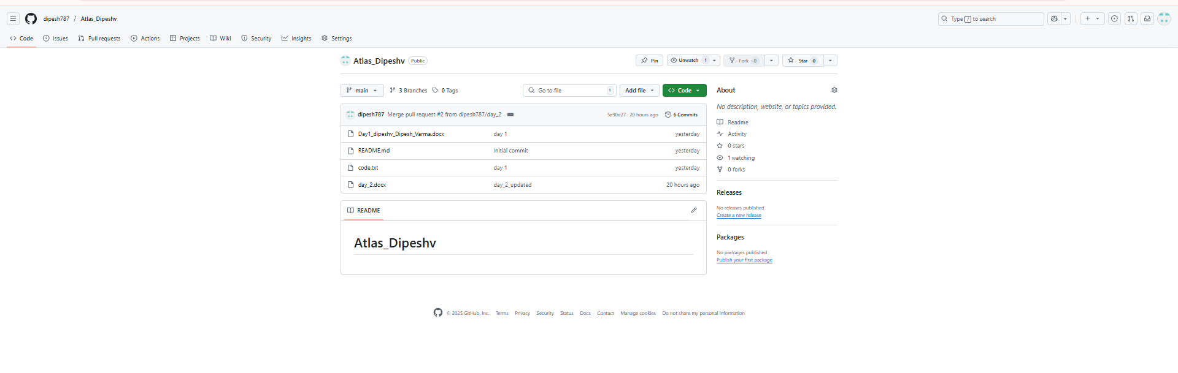
Task 2:
Add a file to your repo using GUI
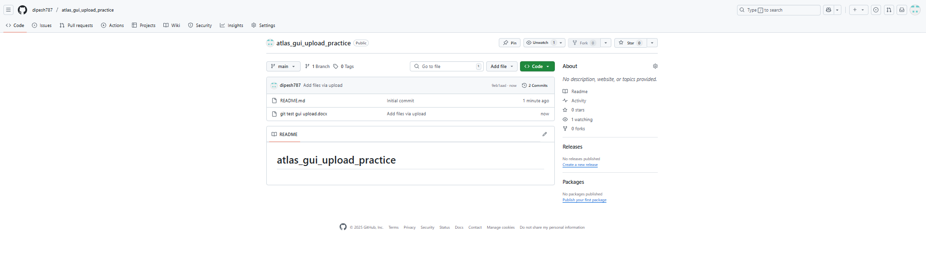

Task 3:
Create a folder in your vm and create a test file 1 and 2 and try to push file1 to the repo
(use git commands)
Git push Via BASH.
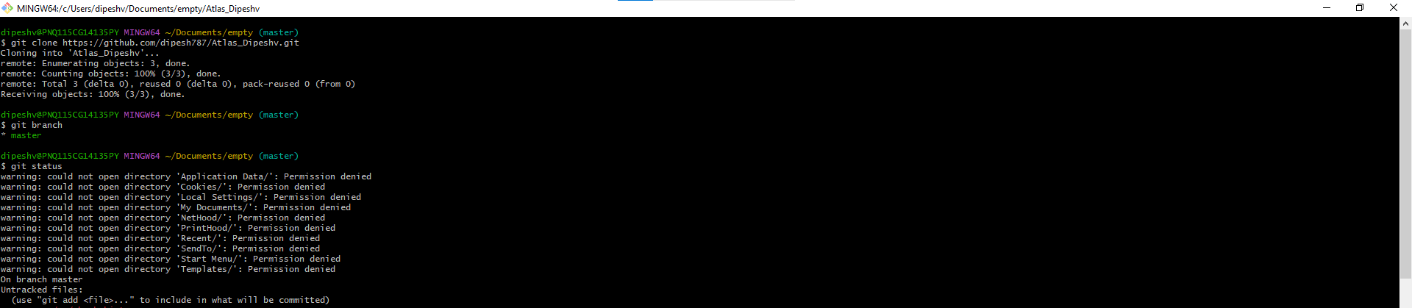
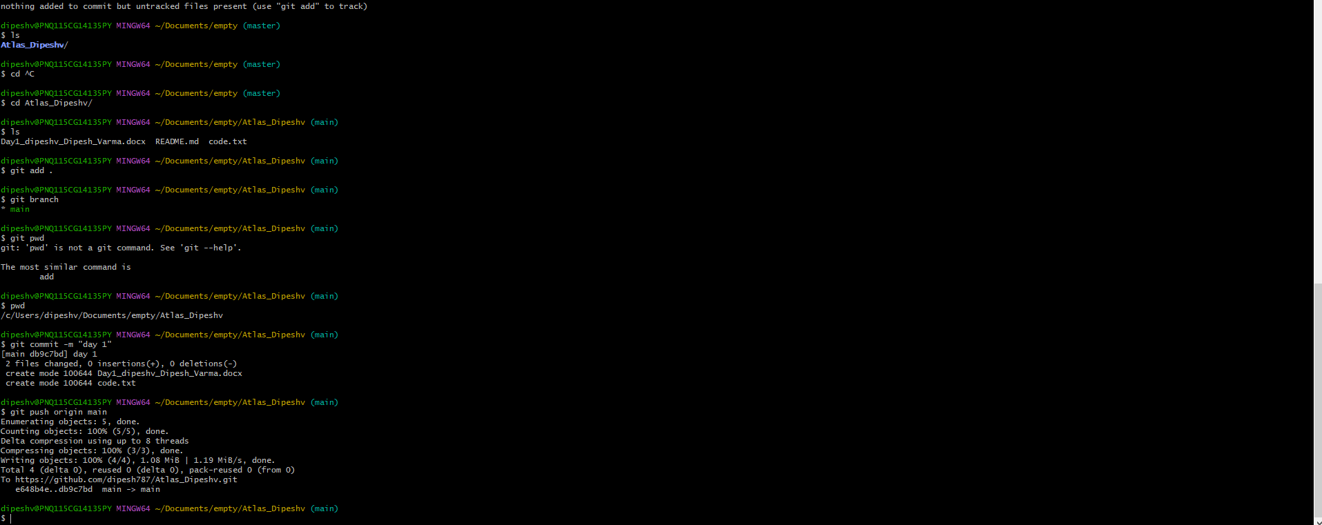

Git New branch creation and push via BASH.
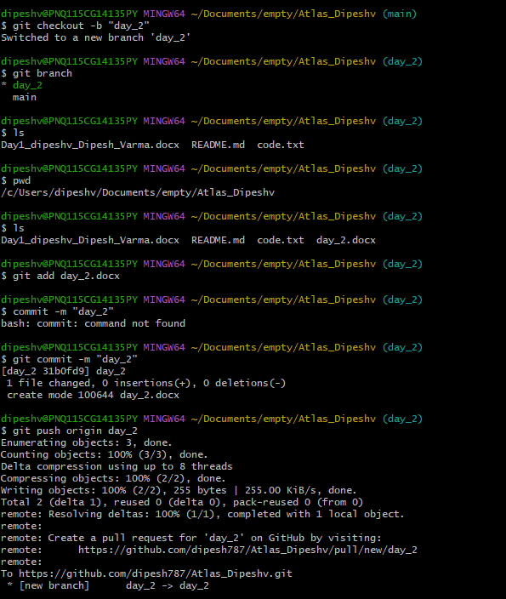

To stash
Git stash
Git stash apply
Git stash pop
Git stash list
Git stash drop stash@{1}
To clear all stashes
Git stash clear

To reset
git reset <file name>
or
git reset.

